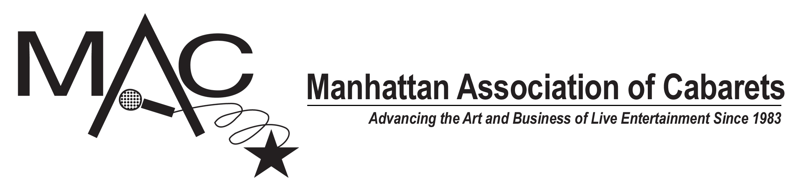
FOR IMMEDIATE RELEASE
Tuesday, April 16, 2024
LIZ CALLAWAY, ANN HAMPTON CALLAWAY,
JEFF HARNAR, GABRIELLE STRAVELLI
AMONG THE WINNERS!

The 38th MAC Award Winners were announced Monday, April 15, 2024 at a LIVE ceremony at NYC’s Symphony Space. As previously announced, VIVIAN REED, LEE ROY REAMS and JEAN-PIERRE PERREAUX received Lifetime Achievement Awards and MARCIA RONEY received the Hanson Award, in a show directed by AMY WOLK and produced by JULIE MILLER.

Here are the 2024 MAC Award winners:

FEMALE VOCALIST
Mardie Millit

MALE VOCALIST
Justin Dylan Nastro

MAJOR ARTIST - FEMALE
Meg Flather

MAJOR ARTIST - MALE
Eric Comstock

NEW YORK DEBUT – FEMALE
Camille Diamond

NEW YORK DEBUT – MALE
Woody Regan

CELEBRITY ARTIST
Gabrielle Stravelli

IMPERSONATION / CHARACTERIZATION / DRAG ARTIST
Amanda Reckonwith (David Sabella)

MUSICAL COMEDY PERFORMER
Lynda Rodolitz

MAJOR DUO/GROUP
Ann Hampton Callaway and Liz Callaway

REVUE
Forbidden Sondheim: Merrily We Stole A Song
Parody lyrics and direction by Gerard Alessandrini, musical direction by Fred Barton, produced by Playkill 11 Productions, John Freedson, Harriet Yellin, Gerard Alessandrini, Christine Pedi

RECURRING SERIES
The Lineup with Susie Mosher

EMCEE
Susie Mosher
The Lineup with Susie Mosher

SPECIAL PRODUCTION
Mama’s Next Big Act
Produced by Don't Tell Mama and Lennie Watts

PIANO BAR/RESTAURANT SINGING ENTERTAINER – UPTOWN
Alison Nusbaum

PIANO BAR/RESTAURANT SINGING ENTERTAINER – DOWNTOWN
Maria Gentile

PIANO BAR INSTRUMENTALIST – UPTOWN
Bill Zeffiro

PIANO BAR INSTRUMENTALIST – DOWNTOWN
Gerry Dieffenbach

ENSEMBLE INSTRUMENTALIST
Steve Doyle, bass

DIRECTOR
Jeff Harnar

MUSICAL DIRECTOR
Tracy Stark

TECHNICAL DIRECTOR
Alison Nusbaum

SONG
“Annie”
Music by Michele Brourman; Lyrics by Hillary Rollins

COMEDY/NOVELTY SONG
“What Are You Doing Rosh Hashanah Eve?”
Music by Eden Casteel; Lyrics by Dan Chaika and Eden Casteel

RECORDING (LAMOTT FRIEDMAN RECORDING AWARD)
Bob Levy featuring Dane Vannatter
Ever Since We Met: The Dane Vannatter Recordings

MAJOR RECORDING
Jeff Harnar
A Collective Cy: Jeff Harnar Sings Cy Coleman

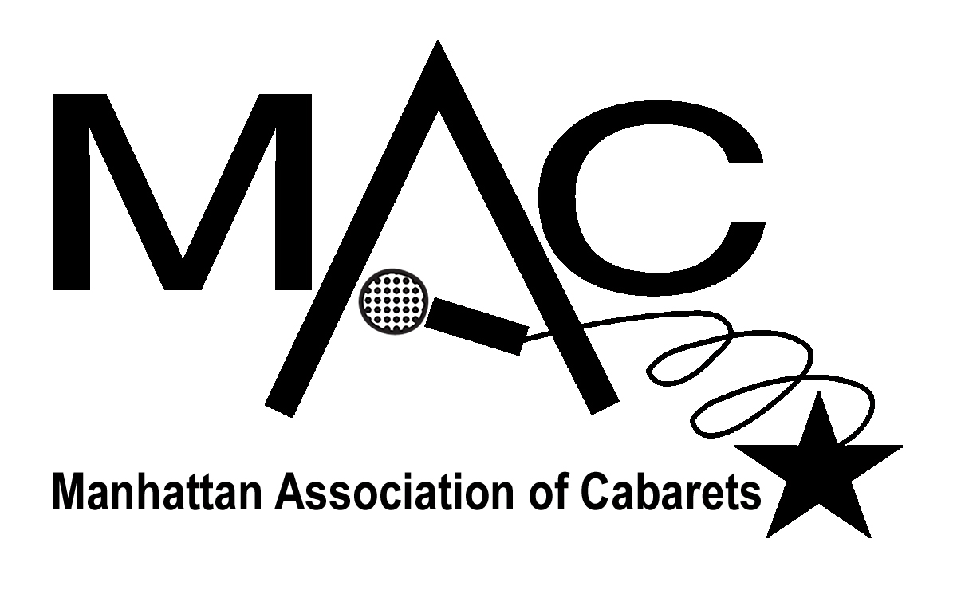
Frank Dain, MAC PR
MACpressrelease@gmail.com; www.macnyc.com

