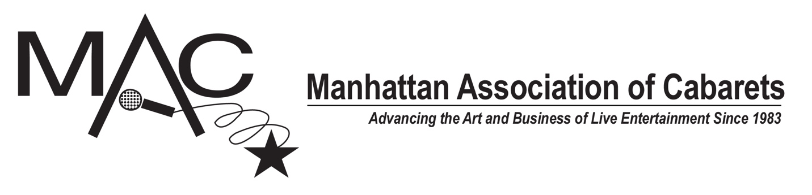
FOR IMMEDIATE RELEASE
July 14, 2022
NOW ACCEPTING SUBMISSIONS FOR THE 2022 DOTTIE BURMAN AND JOHN WALLOWITCH SONGWRITING AWARDS
OPEN TO EVERYONE • DON’T NEED TO BE A MAC MEMBER • NO SUBMISSION FEES OF ANY KIND
$500 CASH PRIZE!
MAC invites all songwriters to submit their original songs for consideration for one of MAC's two songwriting awards: the Dottie Burman Award and the John Wallowitch Award.

Submitters do not need to be MAC members. There is no submission fee. MAC encourages all songwriters to submit their work for consideration.

Submissions must be received by Friday, August 19, 2022.

The selected songwriter or songwriting team for each award will receive $500. To qualify, each submitter must submit three original songs they have written at any time that in their own opinion represent their best work and the range of their writing style. Judging will take place throughout the month of September. The recipients of each award will be announced in October.

If you have any questions, please email us at: info@MACnyc.com

The eligibility rules and submission information for each of the awards is listed below.

FOR THE DOTTIE BURMAN AWARD
The recipient writer or writing team will receive $500.
Eligibility Qualifications:
To be eligible:
1. The songwriter or songwriting team must be 40 years of age or over.
2. The songwriter(s) should not have already received significant recognition in the music industry. For example, the songwriter cannot have won a major award such as a Grammy Award®, nor gained national name recognition outside of the songwriting community.
3. You may not submit a song that previously won a MAC Award. In addition, you may not submit a song that was previously nominated for a MAC Award in the past 3 years. If you previously won the John Wallowitch Award from MAC, you are not eligible to submit for the Dottie Burman Award. You may only receive the Dottie Burman Award once.
4. The Judges review the submitted songs anonymously, without knowledge of the identity of the songwriter(s) who wrote the songs. Therefore, the songs you submit must not contain the songwriter(s) name in the title of the song or body of the lyric.
5. Collaborations are eligible, provided that: (a) all of the collaborators meet the qualifications, (b) all three submitted songs were written by the same writing team, and (c) none of the collaborators is also submitting individually or is a member of another writing team that is entering into the competition.

How to Submit:
Submissions are made by email. Each submitter or submitting writing team will submit a total of three songs.
1. Each song must be in mp3 format. The name of the song should be the title of the mp3 file. For example:
See You in September.mp3
2. In addition, for each song, you must submit a separate WORD document that contains the full lyrics of the song. This should be a single page (or two, if necessary), that contains just the title of the song and the lyrics. Please do not submit pages from a script that also contain character names or stage directions. That document should also be named with just the title of the song. For example:
See You in September.docx
3. Your submission will consist of a single email that contains six attachments – three mp3 (or mp4) audio files, and three WORD documents that contain the full lyrics to one of the three songs, respectively.
4. In the body of the email, you must include your name and contact phone number, as well as the name, contact phone number and contact email for your collaborators, if any. If you are submitting as part of a writing team, please make sure your collaborators have consented to the submission of their work.
5. Email your single submission email with its six attachments to:
SUBMISSION EMAIL: BurmanAward@gmail.com
You will receive an immediate automated reply to acknowledge that your email was received.
Submissions must be received by August 19, 2022.

FOR THE JOHN WALLOWITCH AWARD
The recipient writer or writing team will receive $500.

Eligibility Qualifications:
To be eligible:
1. The songwriter or songwriting team must be 39 years of age or under.
2. The songwriter(s) should not have already received significant recognition in the music industry. For example, the songwriter cannot have won a major award such as a Grammy Award ®, nor gained national name recognition outside of the songwriting community. In addition, the submitter must not have previously won an award from MAC for songwriting.
3. You may not submit a song that previously won a MAC Award. In addition, you may not submit a song that was previously nominated for a MAC Award in the past 3 years. You may only receive the John Wallowitch Award once.
4. The Judges review the submitted songs anonymously, without knowledge of the identity of the songwriter(s) who wrote the songs. Therefore, the songs you submit must not contain the songwriter(s) name in the title of the song or body of the lyric.
5. Collaborations are eligible, provided that: (a) all of the collaborators meet the qualifications, (b) all three submitted songs were written by the same writing team, and (c) none of the collaborators is also submitting individually or is a member of another writing team that is entering into the competition.

How to Submit:
Submissions are made by email. Each submitter or submitting writing team will submit a total of three songs.
1. Each song must be in mp3 format. The name of the song should be the title of the mp3 file. For example:
See You in September.mp3
2. In addition, for each song, you must submit a separate WORD document that contains the full lyrics of the song. This should be a single page (or two, if necessary), that contains just the title of the song and the lyrics. Please do not submit pages from a script that also contain character names or stage directions. That document should also be named with just the title of the song. For example:
See You in September.docx
3. Your submission will consist of a single email that contains six attachments – three mp3 audio files, and three WORD documents that contain the full lyrics to one of the three songs, respectively.
4. In the body of the email, you must include your name and contact phone number, as well as the name, contact phone number and contact email for your collaborators, if any. If you are submitting as part of a writing team, please make sure your collaborators have consented to the submission of their work.
5. Email your single submission email with its six attachments to:
SUBMISSION EMAIL: WallowitchAward@gmail.com
You will receive an immediate automated reply to acknowledge that your email was received.

Submissions must be received by August 19, 2022.

About the Awards
John Wallowitch and Dottie Burman were beloved songwriters in the cabaret community. When Dottie Burman passed away, her estate bequeathed $5,000 dollars to MAC to set up a songwriting competition in her name that would award a cash prize to songwriters aged 40 and over who have not yet received recognition for their writing talents. The MAC Board passed a motion to create a matching award in John Wallowitch’s name to honor songwriters under 40. The finalists are chosen by a panel of judges, and the final decision is made by a celebrity judge from the world of cabaret. Past judges include John McDaniel (2021), Joe Iconis (2021), Barb Jungr (2014), Lauren Molina (2013), Ann Hampton Callaway (2012), Karen Mason (2011), and Sharon McNight (2017).

Past winners have included Sammy Buck & San Acquisto, Sam Carner & Derek Gregor, Patrick Dwyer, Amy Englehart, Drew Fornarola, Harriet Goldberg, Adam Gwon, Joe Iconis, Kenneth Jones & Gerald Stockstill, Shaina Taub, Sam Willmott, Amanda Yesnowitz & Deborah Abramson, Jeff Thomson & Jordan Mann, and Adam Watcher.

Inquiries: macpressrelease@gmail.com

Visit: www.macnyc.com

