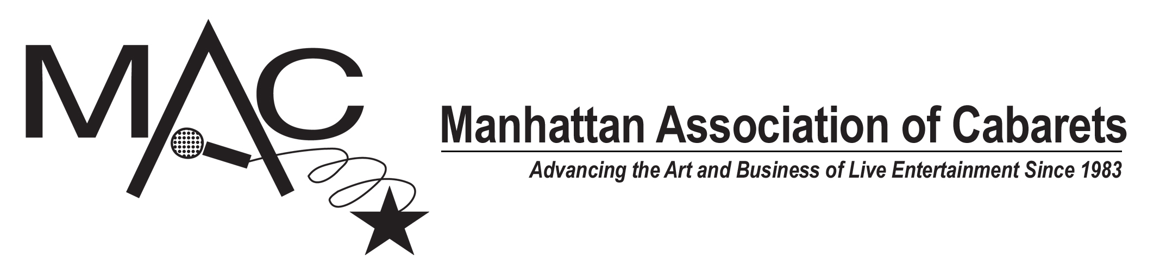

FOR IMMEDIATE RELEASE
March 27, 2019

ANITA GILLETTE, NATALIE DOUGLAS, JEFF HARNAR AMONG THE 2019 MAC AWARD WINNERS

2019 MAC Award Winners Announced!
The 33rd Annual MAC Awards were handed out last night (Tuesday, March 26, 2019) during a glitzy evening at New York City’s SONY Hall.

As previously announced, KAREN MASON received the Lifetime Achievement Award, JOE ICONIS received the Board of Directors Award, MIDNIGHT AT THE NEVER GET received Show of the Year, BEN CAMERON and his BROADWAY SESSIONS received the Ruth Kurtzman Benefit Series Award, and TERESA FISCHER received the Hanson Award.

Here are the 2019 MAC Award winners, voted on by the active MAC members.

FEMALE VOCALIST
JOSEPHINE SANGES

MALE VOCALIST
JEFF MACAULEY

MAJOR ARTIST – FEMALE
NATALIE DOUGLAS

MAJOR ARTIST – MALE
SIDNEY MYER

NEW YORK DEBUT – FEMALE
SIERRA REIN

NEW YORK DEBUT – MALE
TIM CAHILL

CELEBRITY ARTIST
ANITA GILLETTE

IMPERSONATION/CHARACTERIZATION/DRAG ARTIST
DORIS DEAR

MAJOR IMPERSONATION/CHARACTERIZATION/DRAG ARTIST
BenDeLaCreme

MUSICAL COMEDY PERFORMER
IRA LEE COLLINGS

DUO/GROUP
EVELYN SULLIVAN & JASON ELLIS

MAJOR DUO/GROUP
MARCUS SIMEONE, LINA KOUTRAKOS, SEAN HARKNESS

RECURRING SERIES
RICKY RITZEL’S BROADWAY

SPECIAL PRODUCTION
MAMA'S NEXT BIG ACT!

EMCEE
BOBBIE HOROWITZ

DIRECTOR
JEFF HARNAR

MUSICAL DIRECTOR
TRACY STARK

TECHNICAL DIRECTOR
JEAN-PIERRE PERREAUX

ENSEMBLE INSTRUMENTALIST
MATT SCHARFGLASS, bass

PIANO BAR/RESTAURANT INSTRUMENTALIST
RICK JENSEN

PIANO BAR/RESTAURANT SINGING ENTERTAINER – MALE
TOMMY J. DOSE

PIANO BAR/RESTAURANT SINGING ENTERTAINER – FEMALE
TARA MARTINEZ

RECORDING (LaMott Friedman Award)
SHEREE SANO, Live Acts

MAJOR RECORDING
MARISSA MULDER, Two Tickets Left

SONG
“BEST AS I CAN”
Music by Alex Rybeck, lyrics by Bob Levy

COMEDY/NOVELTY SONG
“WTF, DISNEY”
Music and lyrics by Brett Kristofferson

